Pokhara University

Level: Bachelor | Semester – Spring | Year : 2009
Programme: BE |  | Full Marks : 100
 |  | Pass Mark : 45
Course: Applied Mechanics |  | Time : 3 hrs

Candidates are required to give their answers in their own words as far as practicable.
The figures in the margin indicate full marks.

Attempt all the questions.

1. | - Three cables pull on the pipe such that they create a resultant force having magnitude F_{R} = 900 N. If two of the cables are subjected to known forces F₁=600 N and F₂=400N, as shown in the figure, determine the direction θ of the third cable so that the magnitude of force F in this cable is a minimum. What is the magnitude of F? Given: α=45°, β=30°.  - Determine the direction θ (0° ≤ θ≤ 180°) of the force F = 40 N so that it produces (a) the maximum moment about point A and (b) the minimum moment about point A. Compute the moment in each case. Take a = 8 m and b = 2 m. | 7  8
2. | - Determine by direct integration the centroid of the shaded as shown in fig.  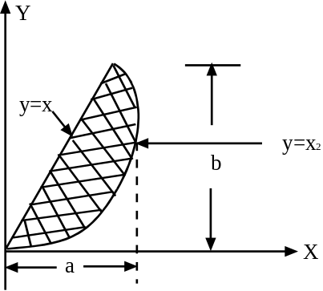  y=x²  - Determine the smallest force P for which equilibrium of the 7.5 kg block is maintained. Take µs = 0.45 and µk = 0.35. | 7  8
3. | - The acceleration of a particle is directly proportional to the time. At times t = 0 sec the velocity of a particle v = -16m/s. Knowing that both of the velocity and the position co-ordinate are zero when t= 4 sec. Write the equation of motion for the particle.  - A rocket is fired vertically from a launching pad at B. Its flight is tracked by radar from point A. Determine the velocity and acceleration of the rocket at the instant when θ = 30° and the radar tracking device is turning at dθ /dt=0.6 rad/sec and d²⁻ θ  /dt² = 0.2 rad/sec2; b = 800m. | 7  8
4. | The sphere at A is given a download velocity V₀ and swings in a vertical circle of radius l and center O. Determine the smallest velocity V₀ for which the sphere will reach point B as it swings about point O (a) if AO is a rope, (b) if AO is a slender rod of negligible mass.  OR  The magnitude and direction of the velocities of two identical frictionless balls before they strike each other are as shown. Assuming e = 0.90, determine the magnitude and direction of the velocity of each ball after the impact.  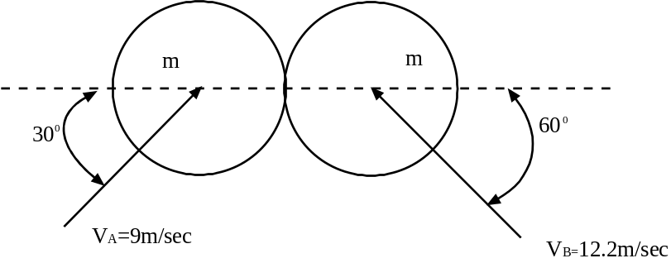 | 15
5. | In a game of billiards, ball A is given an initial a velocity v_{o} along the longitudinal axis of the table. It hits ball B and then ball C, which are both at rest. Balls A and C are observed to hit the sides of the table squarely at A’ and C’, respectively, and ball B is observed to hit the side obliquely at B’. Knowing that v_{o} = 4 m/s, v_{A} =1.92 m/s, and a = 1.65 m, determine (a) the velocities v_{B} and v_{C} of the balls B and C, (b) the point C’ where ball C hits the side of the table, assume frictionless surface and perfectly elastic impacts. | 15
6. | The end B of rod AB as shown in fig moves with a constant velocity V_{B} = 0.9 m/sec (). Determine (a) angular velocity and acceleration of the rod.  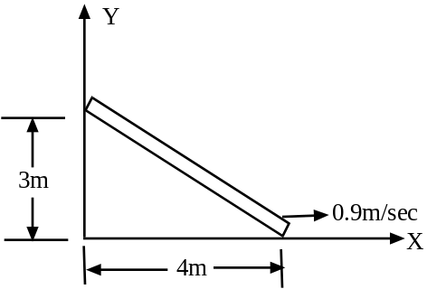 | 15
7. | Write short notes on (Any Two)  - Couple and its characteristics  - Equation of motion in dynamics  - D'Alembert's principle | 2×5

